
Marquette County Medical Care Facility
July 2026 VOL 7

200 Saginaw St. Ishpeming, MI 49849 906-485-1061 www.mqtcmcf.org
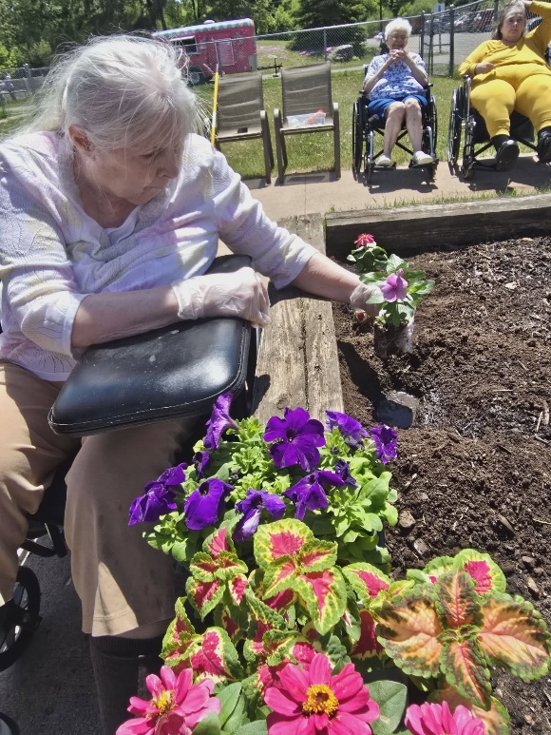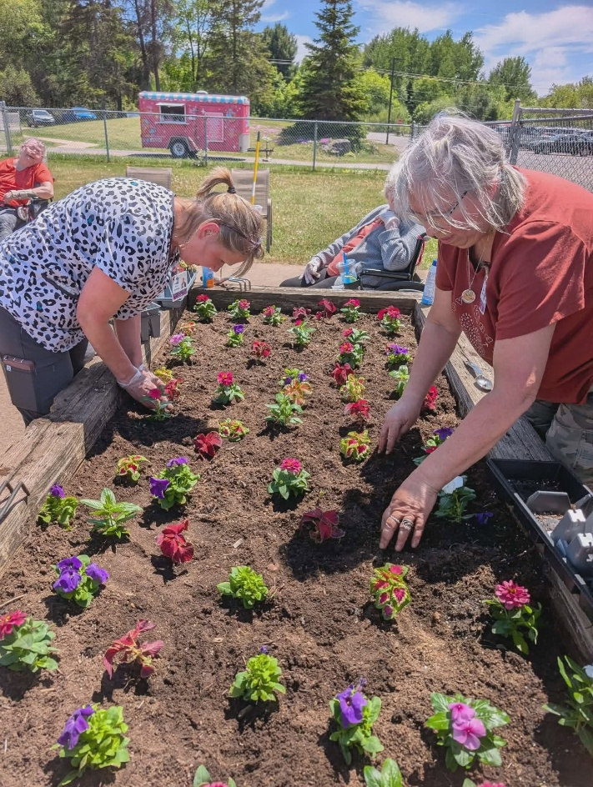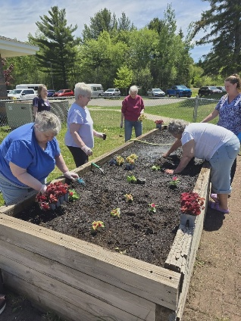 | Residents Birthdays for July  Toni Biron 4th Joann Devold 4th Lowell Cardew 6th  Terry Morcom 10th Nancy Manske 11th Helen Wixtrom 16th  Myrtle Hautamaki 17th Elizabeth Petroff 19th  Ken Sherwood 20th Connie Hager 21st Helen Stolpe 21st  Mary Joki 28th Judy Young-Campbell 28th  Marilyn Loux-Brumley 29th  Employee of the Month  Anna Chipman  Anna is one of those employees that is always on top of everything she does. She is always coming in early, doing extra task to help others out. She is always there to help and make the shift easier. She does things without being asked and when you see her on the shift you know the day is going to go that much better.  Our New Team Members  Jessica Devold, Amy Minthorn, Alyssa Prophet, Abigail Ampe, Cheyenne Bailey, Katelyn Hill, Sheena Morcom, Betty Erkkila, Margaret Miller, Jenifer Zemlock, Scott Carr, Angel Fleis
Employee Anniversary Dates  July 2026  1 Years  Tiffany Lindroos, Cassondra Zampese, Daisy Wheeler, Emma Josefsen  2 Years  Debra Treloar, Ashley Rye  3 Years  Ralph Maki, Bailey Zellar, Hal Timm, Karen Stephens  4 Years  Ryan LaFountain, Kylie Junak, Michelle Wickstrom  6 Years  Kayla Chapman-Durant  13Years  Sarah Morris, Tara kestila  14 Years  Joanne Sartorelli  15 Years  Amanda Tanner, Elizabeth Sullivan  17 Years  Jennie Oja, Sherry Fredin  19 Years  Sheri Hewitt  20 Years  Joseph Richards  21 Years  Amy Nurmela, Kimberly Manier  25 Years  Heather Larson  27 Years  Edward Bayles  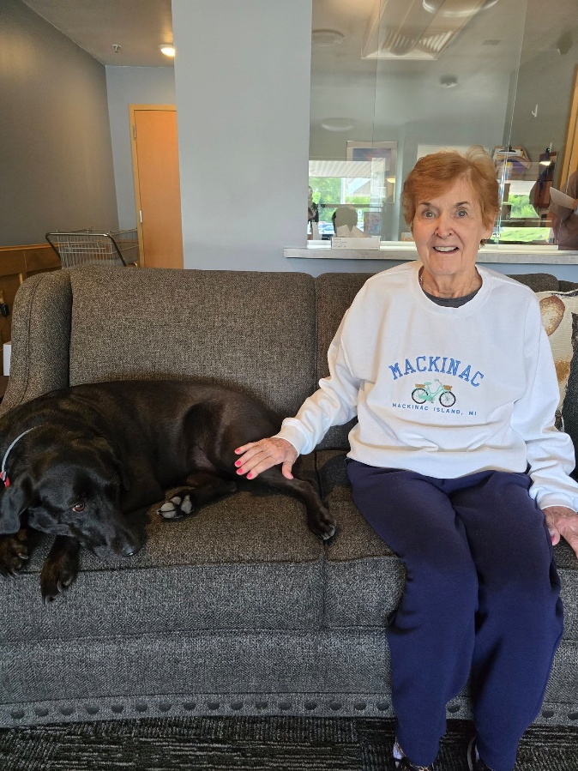 | 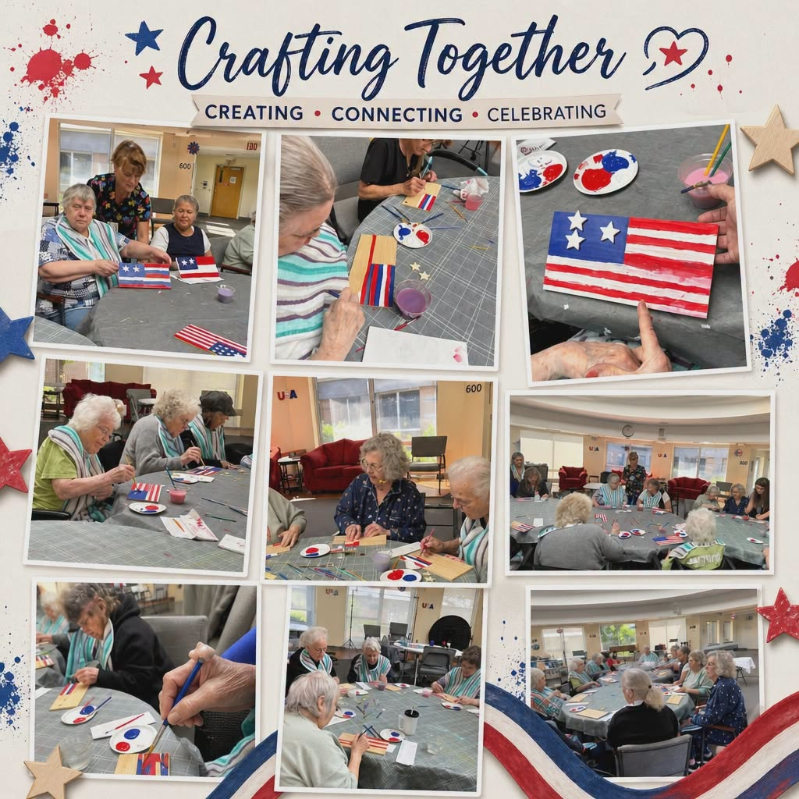  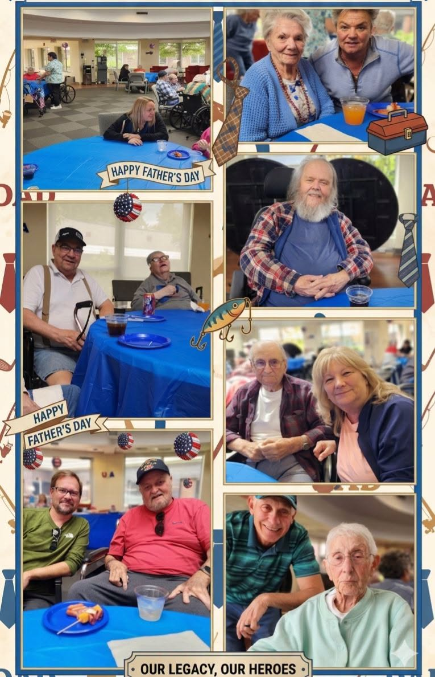

MARQUETTE COUNTY MEDICAL CARE FACILITY

Department of Human Services Board

Caroline Bridges Chairperson
Cindy Adams Board Member
James Heron M.D. Board Member

Administrative Departments

Denise Perry, RN, BSN, Administrator dperry@mqtcmcf.org Ext. 7167

Allecia Filibeck, Assistant Administrator afilibeck@mqtcmcf.org 906-204-1023 or ext. 7123

Krystal Heikkinen, RN, Director of Nursing kheikkinen@mqtcmcf.org 906-204-1046 or ext.7146

Brooke Mitchell, RN, Asst. Dir of Nursing bmitchell@mqtcmcf.org 906-204-1093 or ext. 7139

Theresa Johnson, RN, Education Coordinator tjohnson@mqtcmcf.org 906-204-1074 or ext. 7247

Tina Nelson, RN, Risk Manager tnelson@mqtcmcf.org 906-204-1022 or ext. 7122

Sheri Hewitt, Dietary Manager shewitt@mqtcmcf.org 906-204-1020 or ext. 7248

Micheal Bazinette, Human Resources Mgr. mbazinette@mqtcmcf.org 906-204-1103 or ext. 7103

Nicole Barlock, RN, Admissions nbarlock@mqtcmcf.org 906-204-1061 or ext. 7224

Tami Mallett, Social Work Coordinator tmallett@mqtcmcf.org 906-204-1012 or ext. 7112

Miranda Cobb, Social Worker mcobb@mqtcmcf.org 906-204-1070 or ext. 7170

Joe Morris, Physical Plant Manager jmorris@mqtcmcmf.org 906-204-1069 or ext. 7169

Beckey Grove, Billing rgrove@mqtcmcf.org 906-204-1102 or ext. 7202

Gail Parkkonen, Billing gparkkonen@mqtcmcf.org 906-204-1071 or ext. 7171

Nick Kangas, Activities Coordinator nkangas@mqtcmcf.org 906-204-1021 or ext. 7212

Jeremy Tilton, Special Needs Unit Coord. jtilton@mqtcmcf.org 906-204-1017 or ext. 7227

Jennifer Larson, Health Info. Mgmt. Coord. jlarson@mqtcmcf.org 906-204-1018 or ext.7160
Jodi Wurth, LPN, Resident Care Coordinator jwurth@mqtcmcf.org 906-204-1101 or Ext. 7157

Joanne Sartorelli, LPN, Resident Care Coordinator jsartorelli@mqtcmcf.org 906-204-1099 or Ext. 7158

Elizabeth Sullivan, RN, Resident Care Coordinator esullivan@mqtcmcf.org 906-204-1100 or Ext. 7222

Jolynn Tuomikoski, RN Rehabilitation Coord. jtuomikoski@mqtcmcf.org Ext. 7147
Laura Gauthier, Dietitian lgauthier@mqtcmcf.org Ext. 7220
Kali Curran, RN, Rehabilitation Coordinator kcurran@mqtcmcf.org Ext. 7119



